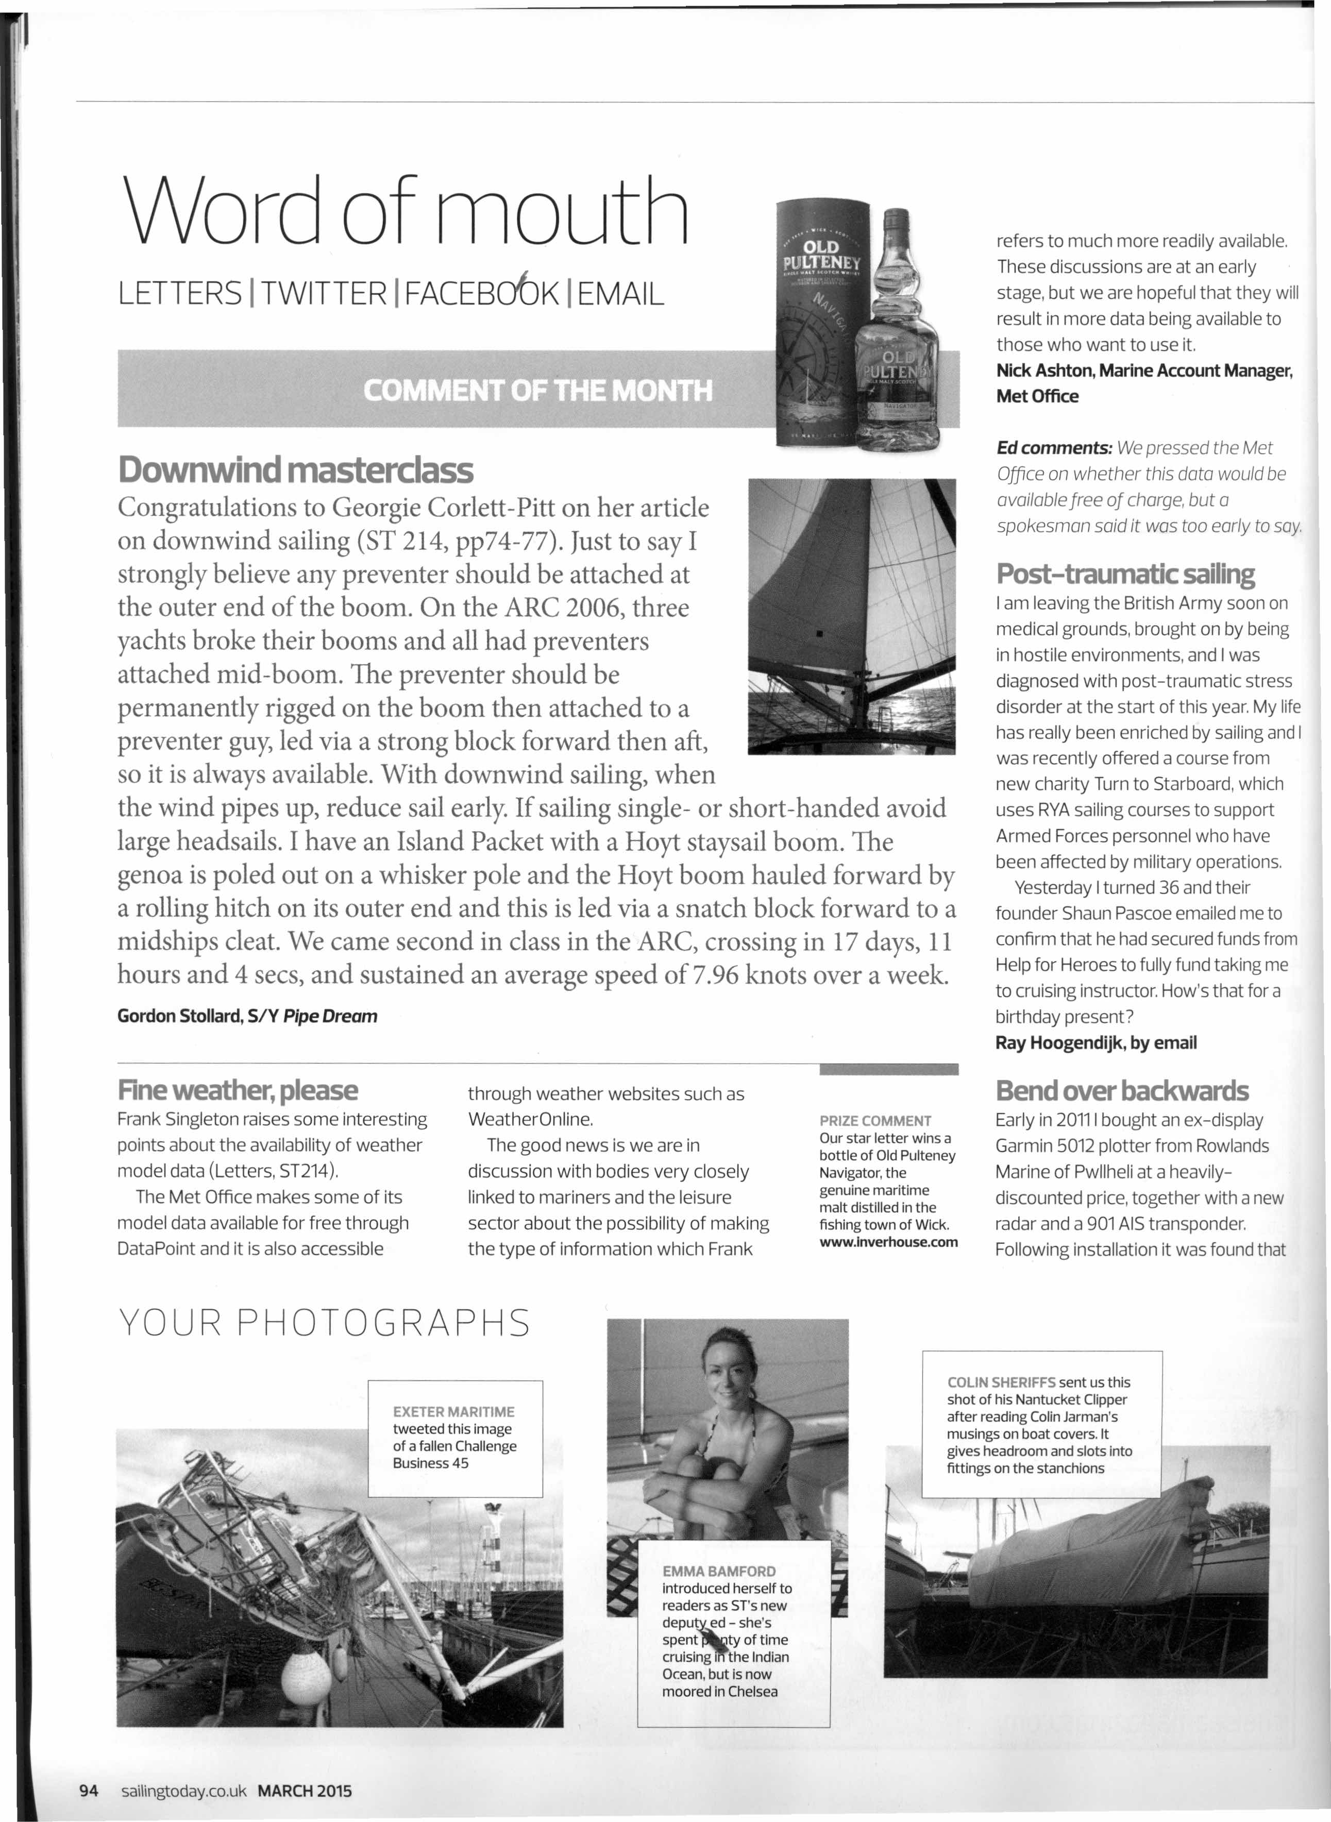

Word of mouth refers to much more readily available.

These discussions are at an early

LETTERS ITWITTER IFACEB06K IEMAIL stage, but we are hopeful that they will

result in more data being available to

those who want to use it.

Nick Ashton, Marine Account Manager, Met Office

*Ed comments:* We *pressed the Met*

**Downwind masterclass** *Office on whether this data would* be

Congratulations to Georgie Corlett-Pitt on her article *available free of charge, but a spokesman said it was too early* to *soy.*

on downwind sailing (ST 214, pp74-77). Just to say I

strongly believe any preventer should be attached at **Post-traumatic sailing**

the outer end of the boom. On the ARC 2006, three I am leaving the British Army soon on

yachts broke their booms and all had preventers medical grounds, brought on by being in hostile environments, and I was

attached mid-boom. The preventer should be diagnosed with post-traumatic stress

permanently rigged on the boom then attached to a disorder at the start of this year. My life

preventer guy, led via a strong block forward then aft, has really been enriched by sailing and I was recently offered a course from

so it is always available. With downwind sailing, when new charity Turn to Starboard, which

the wind pipes up, reduce sail early. If sailing single- or short-handed avoid uses RYA sailing courses to support

large headsails. I have an Island Packet with a Hoyt staysail boom. The Armed Forces personnel who have

been affected by military operations,

genoa is poled out on a whisker pole and the Hoyt boom hauled forward by Yesterday I turned 36 and their

a rolling hitch on its outer end and this is led via a snatch block forward to a founder Shaun Pascoe emailed me to

midships cleat. We came second in class in the ARC, crossing in 17 days, 11 confirm that he had secured funds from

hours and 4 sees, and sustained an average speed of7.96 knots over a week. Help for Heroes to fully fund taking me

to cruising instructor, How's that for a

Gordon Stollard, SlY *Pipe Dream* birthday present?

Ray Hoogendijk, by email

**Fine weather, please** through weather websites such as **Bend over backwards**

Frank Singleton raises some interesting WeatherOnline, PRIZE COMMENT Early in 20111bought an ex-display

points about the availability of weather The good news is we are in Our star letter wins a Garmin 5012 plotter from Rowlands

bottle of Old Pulteney

model data (Letters, ST214), discussion with bodies very closely Navigator, the Marine of Pwllheli at a heavily-

The Met Office makes some of its linked to mariners and the leisure genuine maritime discounted price, together with a new

malt distilled in the

model data available for free through sector about the possibility of making fishing town of Wick. radar and a 901 AIS transponder.

DataPoint and it is also accessible the type of information which Frank [www.lnverhouse.com](http://www.lnverhouse.com/) Following installation it was found that

YOUR PHOTOGRAPHS

COLIN SHERIFFS sent us this shot of his Nantucket Clipper

EXETER MARITIME after reading Colin Jarman's

tweeted this image musings on boat covers. It

of a fallen Challenge gives headroom and slots into

Business 45 fittings on the stanchions

EMMA BAMFORD

introduced herself to readers as ST's new

depu~d - she's

spent ty of time cruising I the Indian Ocean, but is now moored in Chelsea

94 sailingtoday.co.uk MARCH 2015